1. **Fact finding and Data analysis**
2. **Fact Finding technique**
   1. **Interview**

Interview is a method used to collect data and information from face-to-face interviews. The aim of interview is to find, verify, clarify facts, motivate end-users involved, identify requirements and gather ideas and opinions between interviewers and interviewee. In order to make the interview session success, the interviewer must appropriately prepare for the question that need to be asked for the proposed system. Usually, the information collected from interview session is quite accurate and reliable as the interviewer can cross check the doubts and the misunderstanding. Interviewer and interviewee also can discuss about the future problems. (Shah, 2019)

From the interview session that has been held on 17th June 2018, there are many information that has been collected in order to develop the proposed system which is e-Donation Application. The interview has been held within 17 minutes with Chairman of Koperasi KPM Beranang which is En Zakaria bin Rosman. There were about 7 questions for the interview and all the question has been answered. The interview session was made to get all the requirements for the e-Donation Application. The interview outline and report is attached in this report.

* 1. **Observtion**

Observation is one of the fact-finding techniques that has been implemented. Observation is a technique to collect information by observing the business process and current system. By using this technique, the developers have the chance to experience the current system themselves, not just relying on the words of the users. (System Analyst's blog, 2019)

Based on the observation that has been conducted on 17 June 2019 at Encik Zakaria bin Rosman’s space in Science Quantitative Department, there is a file which Encik Zakaria keep in his space. The file only keeps the important letter of the donation application. There is no report that can summarize the yearly donation that has been given to the applicant.

1. **Evidence of Fact-Finding**

|  |  |
| --- | --- |
| **Interview Outline** | |
| **Interviewee: En Zakaria** | **Interviewer: Athirah bt Ahmad Fauzi** |
| **Location: KPM Beranang** | **Date :17/6/2019** |
| **Objectives: To gather requirements and information for e-Donation Application** | **Reminders: - none** |
| **Agenda:** | **Approximate Time:** |
| Introduction | **1 min** |
| Overview of Interview | **1 min** |
| Question 1 | **2 min** |
| Question 2 | **1 min** |
| Question 3 | **1 min** |
| Question 4 | **2 min** |
| Question 5 | **2 min** |
| Question 6 | **2 min** |
| Question 7 | **2 min** |
| Summary of Major Points | **1 min** |
| Question From Interviewee | **1 min** |
| Closing | **1 min** |
| **General Observations: Encik Zakaria gave a good respond within the time.** | |
| **Unresolved Issues: None** | |

* 1. **Interview Outline**
  2. **Interview Report**

|  |  |
| --- | --- |
| **Interviewer** | **Interviewee** |
| Question 1:  What is the current system used to apply and track the donation for the college’s activities? | Our current system right now is manual which is using filing system. The organization/clubs that want to apply for the donation have to write a formal letter and send it to me. While, me as the person in charge who manage the donation application have to file in all the application in one file. |
| Question 2:  What are some of the problems you experience using the current system? | The problem of our current system is we cannot keep track the amount of the donation that has been given to the Organization/Department. |
| Question 3:  How many staff involved in manage the current system? | Me and few others member of Koperasi KPM Beranang are people involve in order to manage the donation that has been applied by the clubs or organization. |
| Question 4:  What kinds of data do you work with? | We manage the data on Name of Program/Events, Date of the Program/Events, Person in Charge, Department/Organization, Amount of Student Involve in the Program, Amount of Donation and Approved Amount of Donation. |
| Question 5:  If we proposed the new system, what are the requirements needed? I mean, the functionality needs to be provided in the system | We need the system that is able to apply for the donation. The system also is able to manage the application of the donation. In the same time, the system also can provide me with the appropriate report which is can summarize the application of the donation. |
| Question 6:  What kind of report would like the system to be able to generate? | Total Amount of Donation Applied by Department/Organization. |
| Question 7:  Do you want the system to be stand-alone or it can be used in college area or even online? | I would like the system to be online system which can be access by the students and staff in our college. |

* 1. 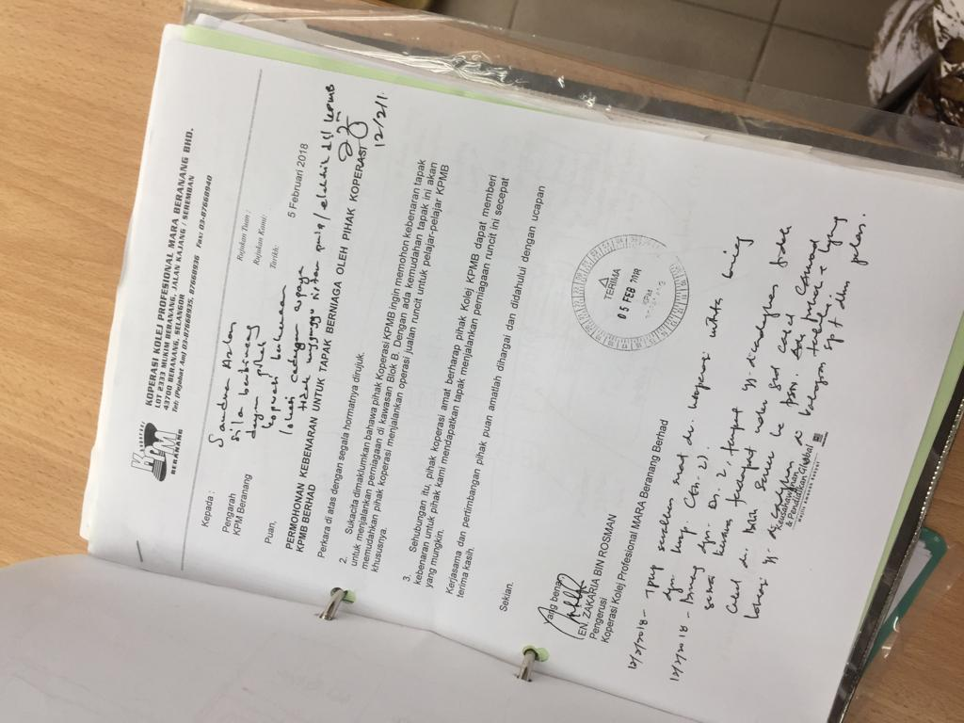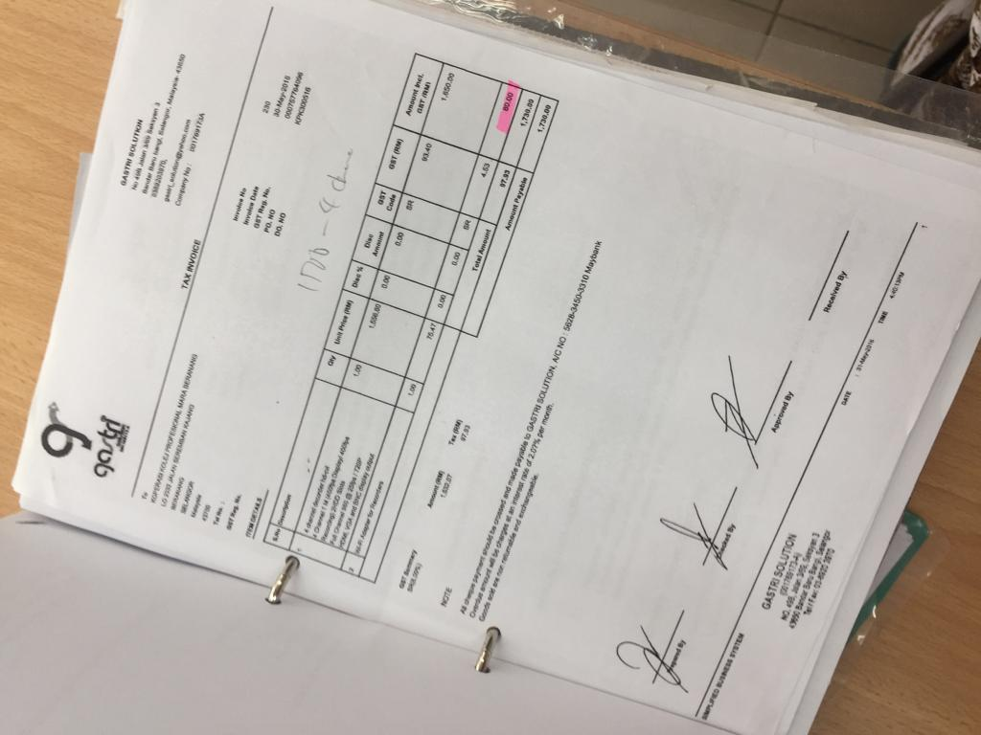**Observation**

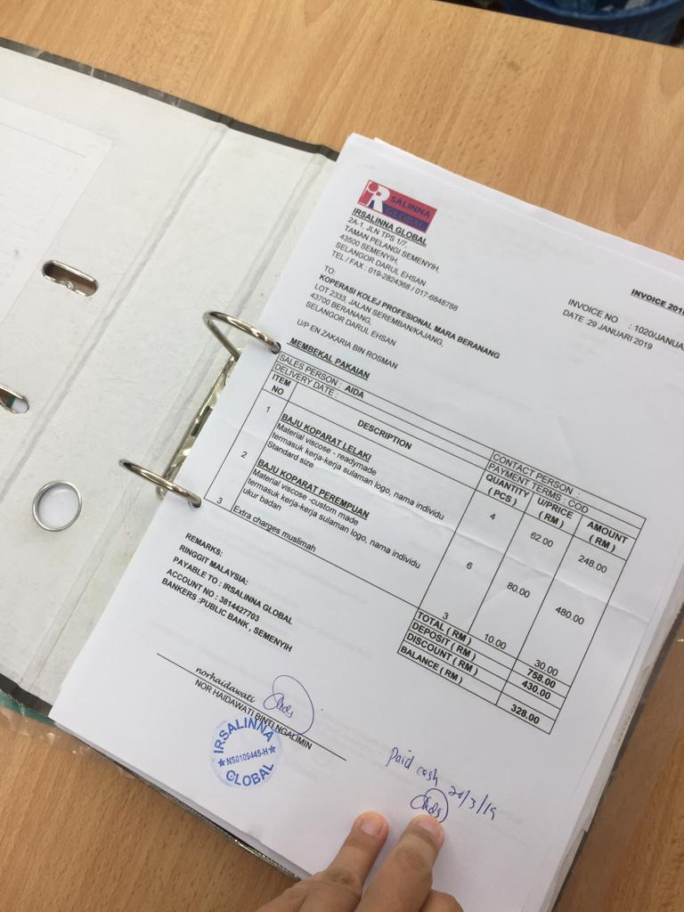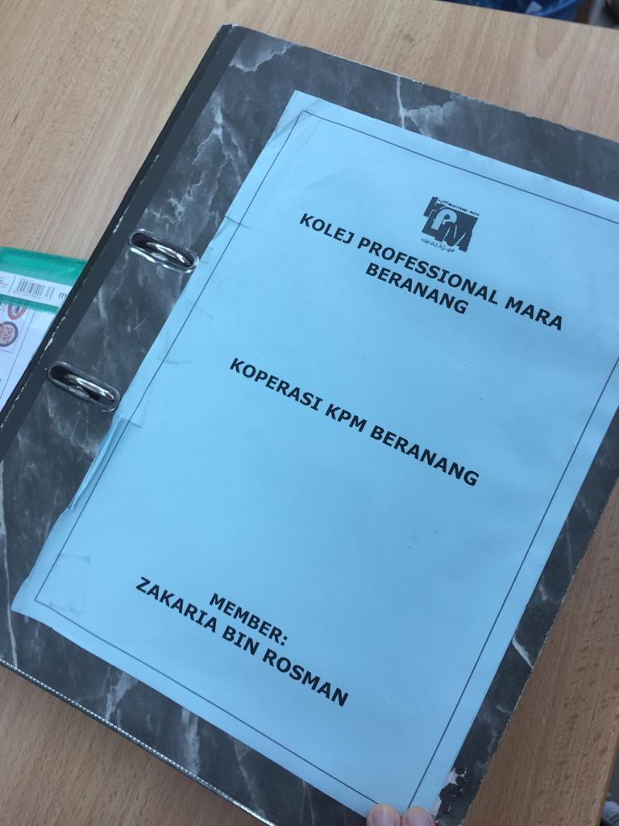**Picture of Document that involved in the process**

1. **Fact-finding Analysis**
   1. **Current Situation**

The current system that has been used by the Koperasi KPM Beranang is manual which is by using filing system. The Organization/Department that want to apply for the donation have to make formal letter and give it to Encik Zakaria for the approval whether the Organization/Department eligible for the donation or not. While, Encik Zakaria bin Rosman, chairman of Koperasi KPM Beranang is the person who manage the donation application which he has to file in all the application in one file.

There is a problem regarding to the current system which is he cannot keep track the amount of the donation that has been given to the same Organization/Department. The current system also lacks of flexibility because the system only can be managed by one person at a time as it used manual filing. Other than that, the staff or students who want to apply for the donation also must write a formal letter and give to chairman of Koperasi KPM Beranang which not flexible.

* 1. **Recommendation**

The name of propose system is e-Donation Application. The system will be online system which can be accessed by the staff and students of KPM Beranang. The system will be implemented with a form which must be filled in by the staff or student in order to apply for the donation. The important data that will be implemented in the form are Name of Program/Events, Date of the Program/Events, Person in Charge, Staff of Koperasi KPM Beranang, Department/Organization, Amount of Student Involve in the Program, Amount of Donation, attachment of notice letter, Email address and Telephone No of the person in charge.

Furthermore, the system also can be signup and logged in by member of Koperasi KPM Beranang. The members can manage the donation by giving approval to the application. The system also can help the members to keep track the amount of the donation that has been given to the Organization/Department. The system also will be able to generate report that can summarize the donation application and summarize total amount of donation that has been given to the organization or department.

* 1. **Significance of Recommendation.**

The system will give positive impact toward the member of Koperasi KPM Beranang and staff and student of KPM Beranang. The system will ease the staff and students of KPM Beranang in order to apply for the donation because the system can be accessed through online. The system also can ease the member of Koperasi KPM Beranang to manage the donation by giving approval to the donation application. They also can easily track the donation that has been approved and given to the Organization/Department. Since the current system need their user to use a lot of paper, the proposed system will help in reducing the paper waste and reducing space to keep all the document. The proposed system will be fully computerized including the application form and the yearly and monthly report.

**References**

1. Shah, B. (2019). Fact Finding Techniques. [online] Systemanalysisanddesign.blogspot.com. Available at: http://systemanalysisanddesign.blogspot.com/2008/11/fact-finding-techniques.html [Accessed 20 Jun. 2019].
2. System Analyst's blog. (2019). Fact-Finding Techniques. [online] Available at: https://systemanalyst1.wordpress.com/2010/11/04/hello-world/ [Accessed 21 Jun. 2019].